**Introduction**

The Kenyan coral reef fishery landings data I have is separated by landings site along the Kenyan coast. Local experts say that we can mostly assume the catch comes from areas near the landing sites (within 1-4 km. sq. surrounding the landing site; T. McClanahan, *personal communication*). While data only comes from fished areas, there are many protected and partially protected marine parks and reserves in the region. Variation in physical characteristics of the fished sites, such as depth, habitat type, and latitude, as well as variation in management and history of fishing pressure, could lead to variable growth between landing sites. It has been shown that maturity and fecundity vary between fished and protected sites (Locham et al. 2015). Therefore, this documented change in fecundity by site could be a hint that there are growth differences by site. While all the sites included in the dataset are of course fished (since the data is from landing sites only), it is possible that boundary effects and other physical characteristics of the system could impact the individual growth rates.

However, it is common practice to pool the length composition data together by stock, removing any accounting for spatial processes that led to the data observed. For example, the Kenyan government’s management plan for rabbitfish, *Siganus sutor*, is pooled for the entire stock within the Kenyan EEZ. The goal of this project is to simulate variable Brody growth coefficient as a 1D spatial process, then generate length composition data arising from each site. We will then estimate the stock status both by location and pooled, to identify where fisheries management could fall short when spatial variability in the growth process is not accounted for.

**Methods**

I generated true values of the Brody growth coefficient (von Bertalanffy k parameter) as a 1D spatial process, assuming process error variability by site, and a trend over approximately the latitude of the Kenyan coastline, from -4 to -1 degrees (Figure 1).



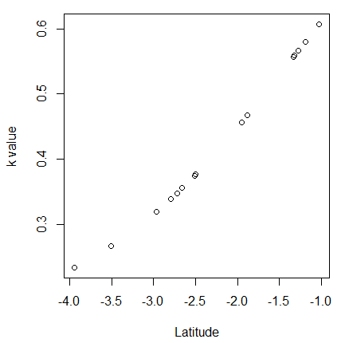

Figure 1. Example of simulated trend and noise in the von Bertalanffy Brody growth coefficient at 15 sites across the latitude of the Kenyan coast. The final project will generate at 1,000 of these trends.

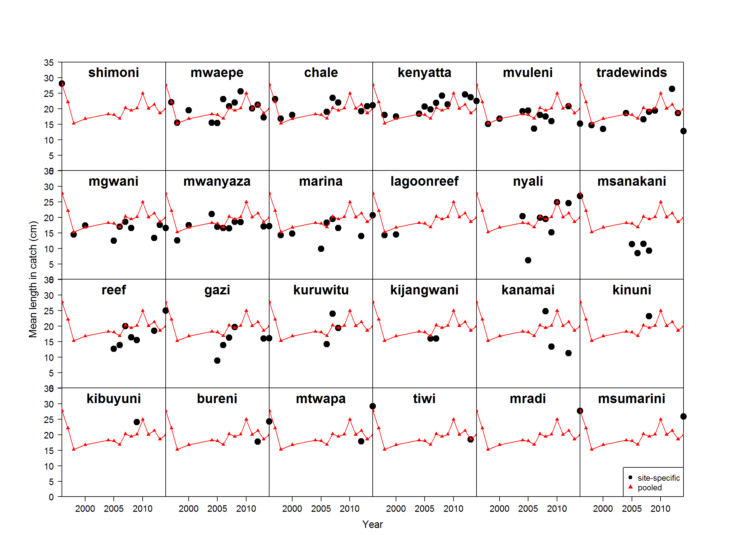

Figure 2. Observed mean length over time of rabbitfish, *Siganus sutor*,from 24 fishery landing sites on the Kenyan coast. Black points represent the mean length at the specific site, and the red triangles and lines represent the pooled mean length of all samples across the Kenyan coast.

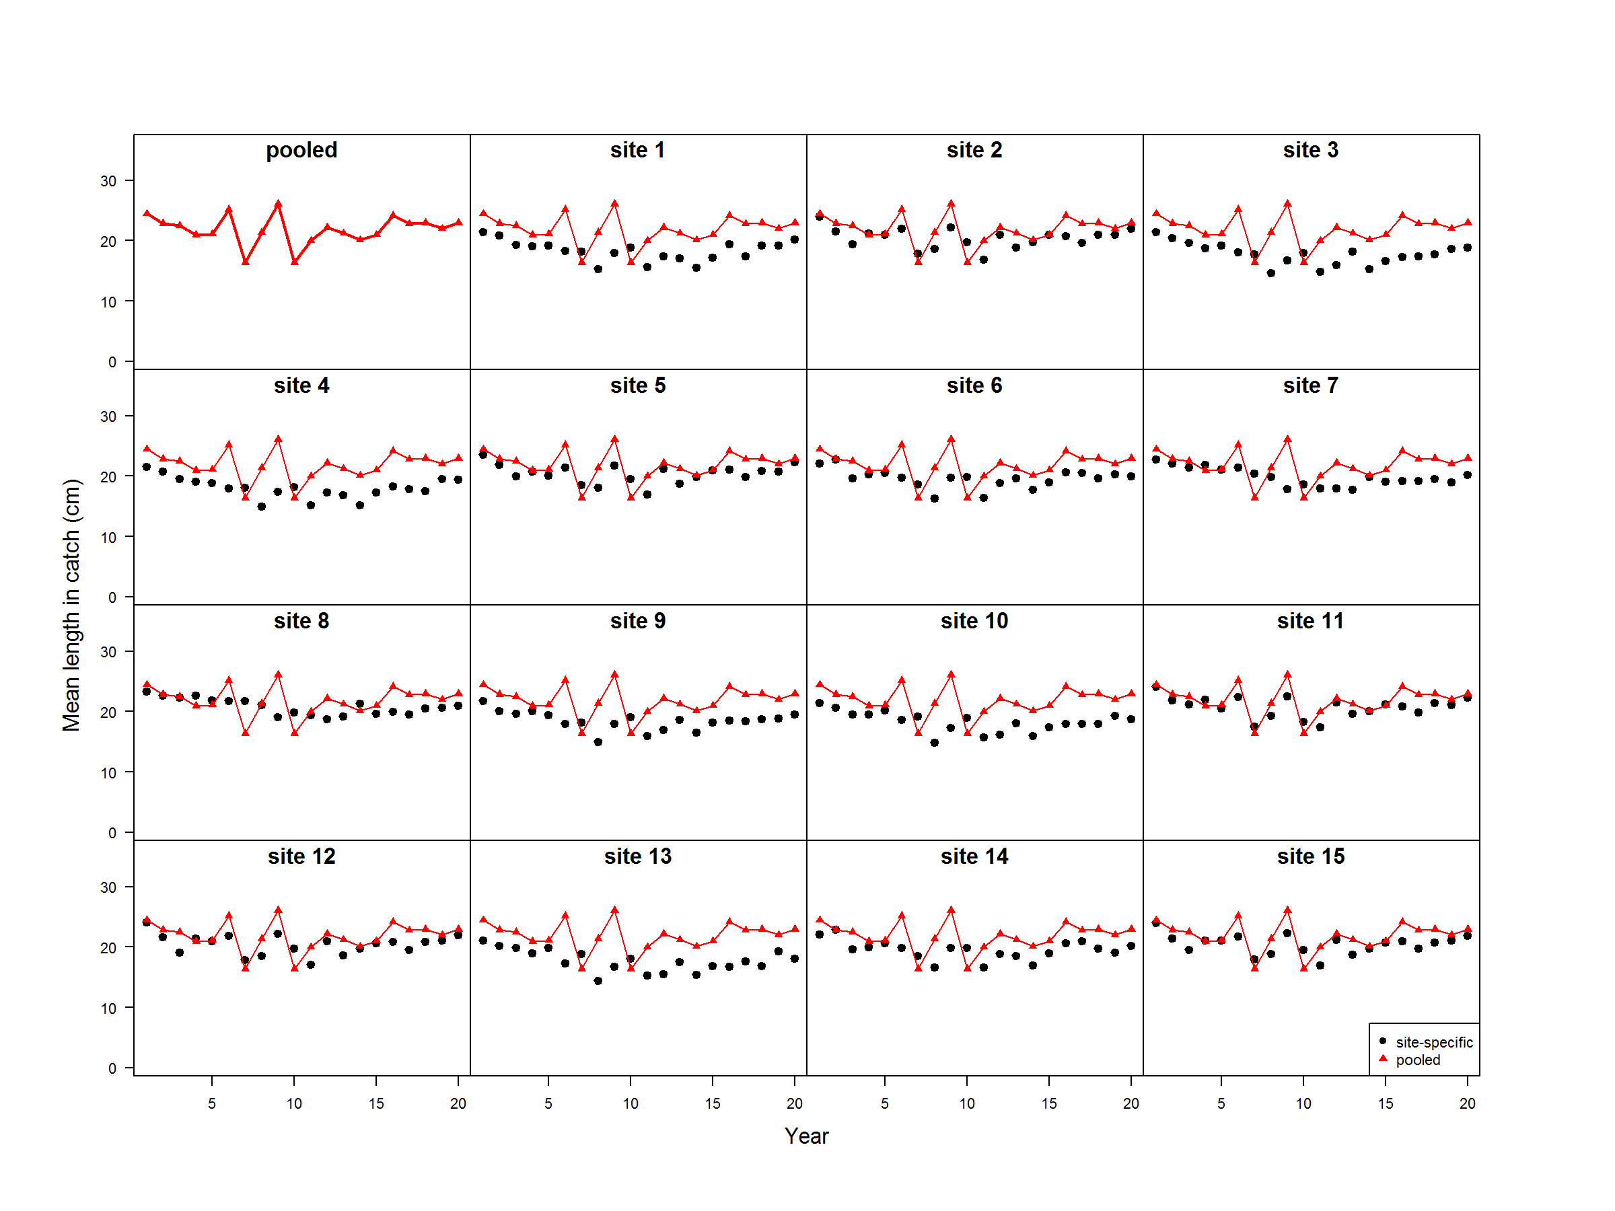

Figure 3. Simulated mean length over time mimicking the life history of rabbitfish, *Siganus sutor*. Red triangles and lines represent the mean length that arises assuming that the individual growth does not vary by area. Black points represent the mean length at a specific site, where the von Bertalanffy Brody growth coefficient varies by site.

1. 2-3 page written description of:

(a) Short (1 paragraph) description of what type of spatiotemporal process is being included and the rationale for including it.

(b) The equations underlying your simulation model with equations for the process and observation components along with definitions of parameters in the equations

(c) Figures of the simulated data

2. R code used to generate the data and make the plots

Spatiotemporal process = varying growth by site, with some temporal differences from environment

Simulation model --- use tools from class to create operating model with spatiotemporal process

Observation model --- length compositions at several sites along coast, with some assumed growth curve

Figure of simulated data – mean length at each site

1. Look at mean length between sites (discuss the fact that some landing sites are inland – why are these differences important?)
2. Simulate varying degrees of spatial variability in growth
   1. K varies – growth (may be based on depth, temperature, nutrients, etc.)
   2. Linf varies – proxy for how depleted the population may be – evolved to not grow as fast
3. Randomly pick points, see where they fall in terms of the growth curve, run OM to generate data
4. Run EM

Use tools from week 4 to simulate data and do simple regression relating covariates